Project 2 Proposal

Group 1: Shobha Somashekar, Ben Sosa, Rey Sosa, Felix Hernandez

Topic & Rationale:

We thought it would be fun to look at what movies are the highest rated, most popular movies in different countries around the world. Are there movies that were highly rated and popular everywhere, or are there variations between countries? Do audiences in different countries prefer different genres of movies?

Datasets:

We are planning to use the *IMDb movies extensive dataset;* (<https://www.kaggle.com/stefanoleone992/imdb-extensive-dataset?select=IMDb+title_principals.csv>) which is composed of four contributing datasets in .csv format.

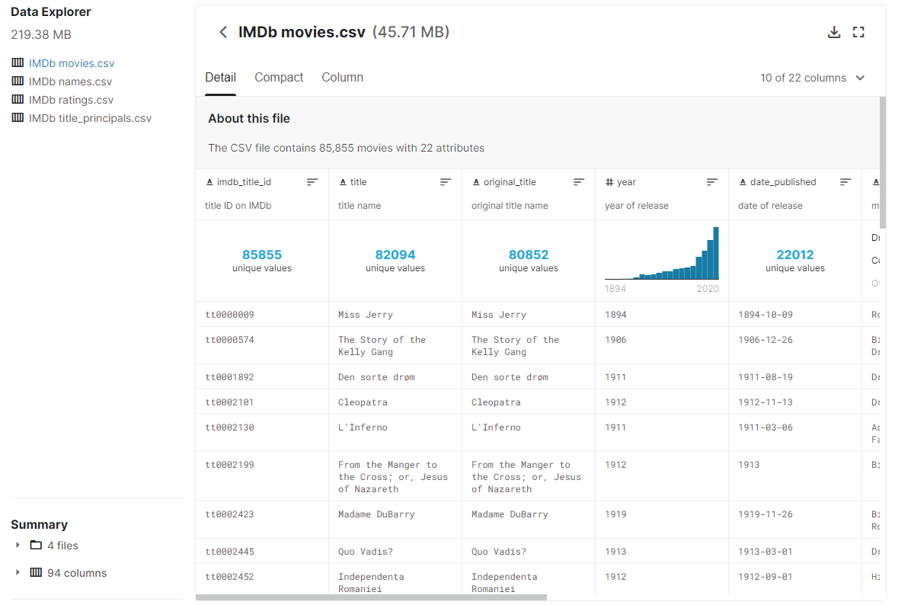

Motivating Screenshots:

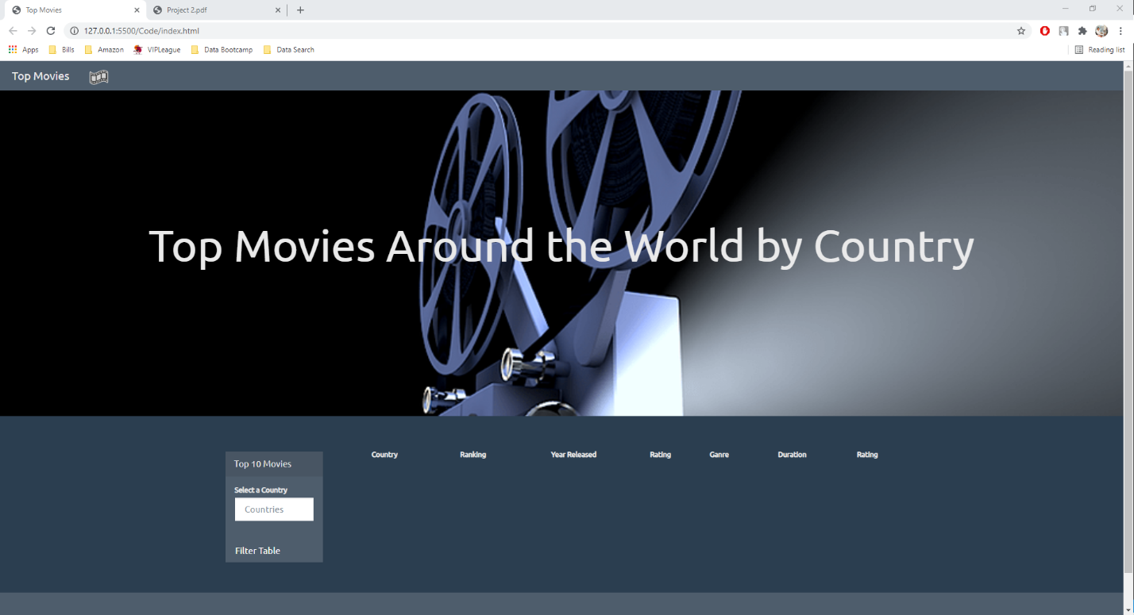

A table could be used to display the ten highest rated, most popular movies in the country/genre selected by the user from dropdown menus.

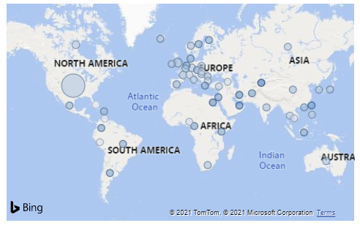

We would like to generate a world map that would be generated based on the user’s selection of country/genre of film from the drop-down menus that would display where that genre is less to more popular if no country was selected but a genre was, and would display the ten most popular movies in a country, irrespective of genre, if only a country is selected. We will explore Lodash and the Datamap JS libraries for use in our project.

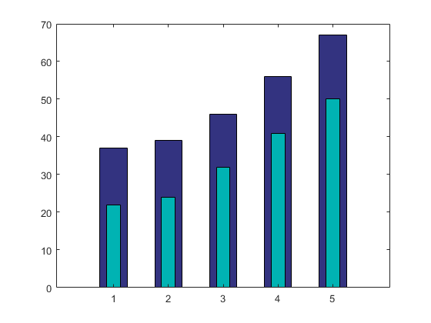

An overlaid bar chart could be used to display Box Office Performance vs. Budget of the 10 highest rated movies based on the user’s country/genre selections.

Sketch of the Final Design:

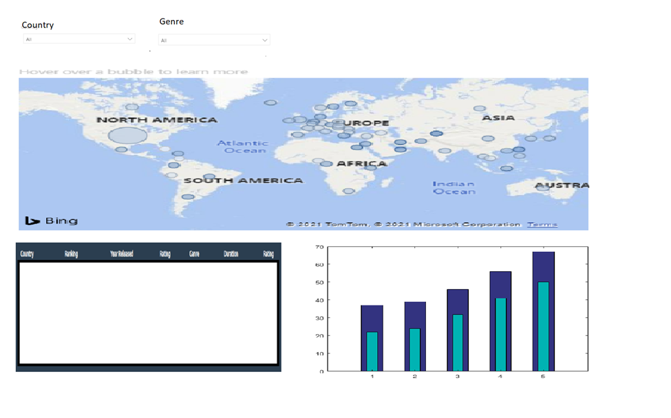

Repository:

<https://github.com/Fhern1954/Project-2-Fantastic-4>.